Editorial Comments-v2 (please reply point-by-point)

- Reference
- The citation of reference 10 is missing, please check and supplement.
>>I have resolved this one.
- The reference list contains 25 entries, whereas 28 citations appear in the main text. Please check and revise to ensure that all in-text citations are correctly listed and that the numbering is consistent between the text and the reference list.
>>I have removed 26,27 and 28
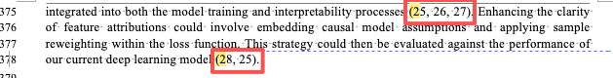
- Please avoid citing preprints in the reference list. Preprints have not undergone peer review and therefore the reliability of their data and conclusions cannot be guaranteed. We recommend replacing these citations (green highlight) with peer-reviewed sources to ensure the academic rigor of the manuscript.
>>I have updated 11,21 and 24
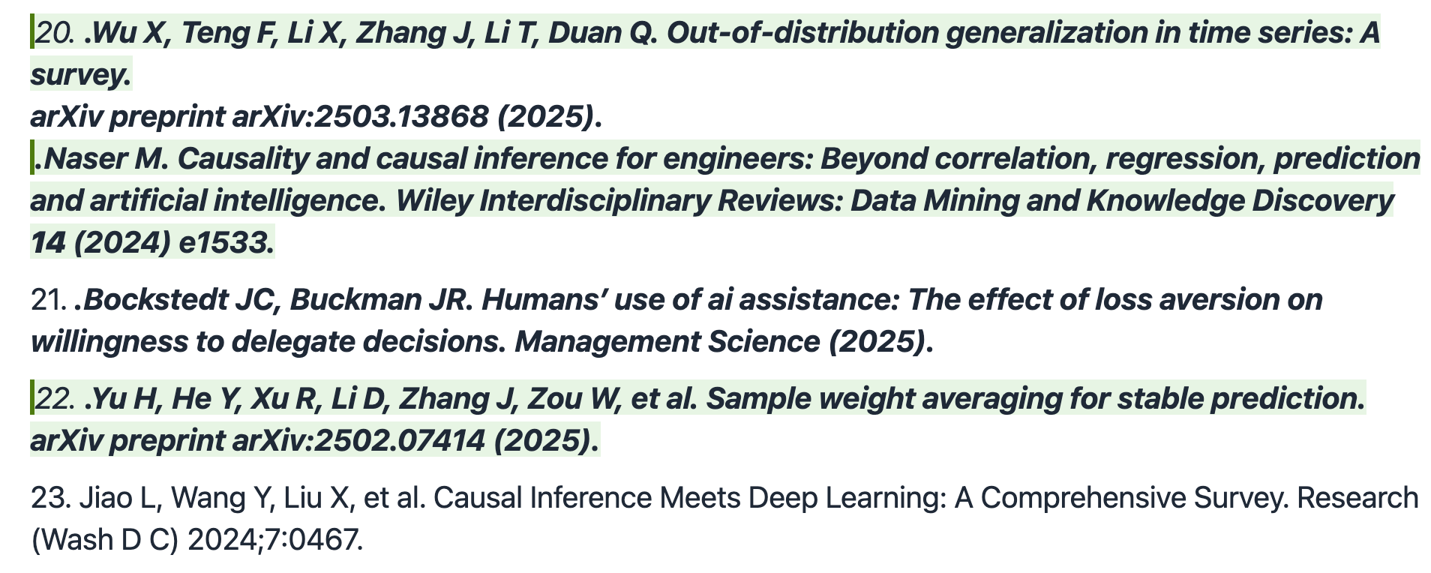

- DSS
- The time period is not clearly described. We recommend revising them to “from the publication date” for item 5 and “within XXX (please specify a suitable time period) for item 6.
>>I have changed them.
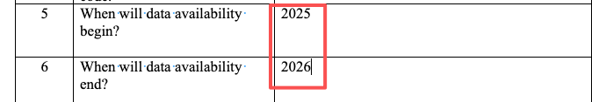
- Please remove the external hyperlink and present the information in text form, as external links are not recommended in the manuscript.
>>I have removed the hyperlink.
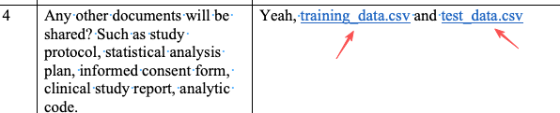

- Ethics: According to the approval letter provided, the correct ethics approval number should be reported as (No. 2024-R703). Please revise the manuscript accordingly to ensure consistency and accuracy.
>>I have changed the previous one into the No. 2024-R703.
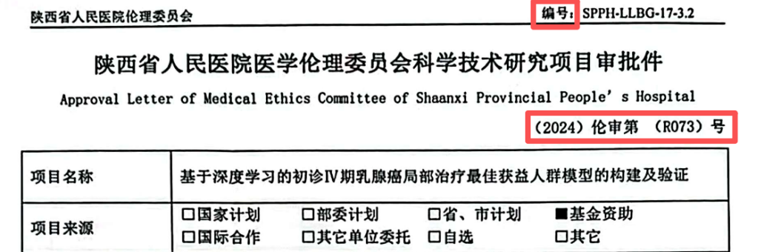
- Figures
  - All figures are not clear enough, please provide them in higher resolution. The preferred format for figures is JPG, TIFF or editable PDF format.
>>I have provided all the figures as jpg.
  - Please provide an editable version of Figure 1 as a stand-alone doc/PPT file for copy-editing.
>>I have provided Figure 1 as a stand-alone doc/PPT file

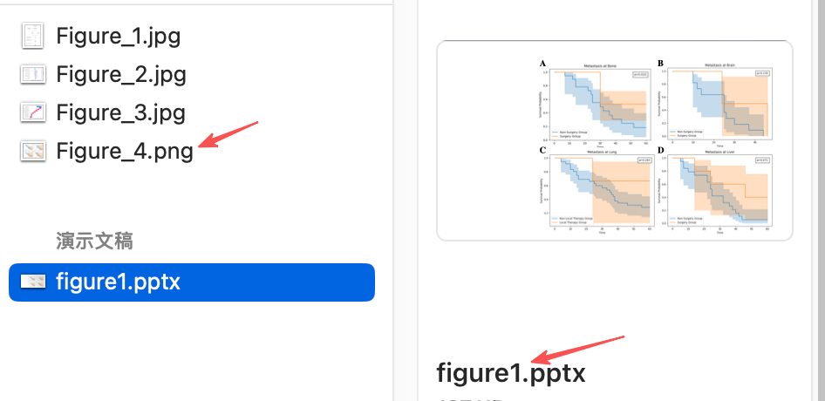
  - Please provide the figure 5 in tiff or jpg format, as figures inserted in Word documents are compressed and may lose image quality.
>>I have provided the figure5 as jpg.

